**VISVESVARAYA TECHNOLOGICAL UNIVERSITY**

**Jnana Sangama, BELAGAVI-590018**

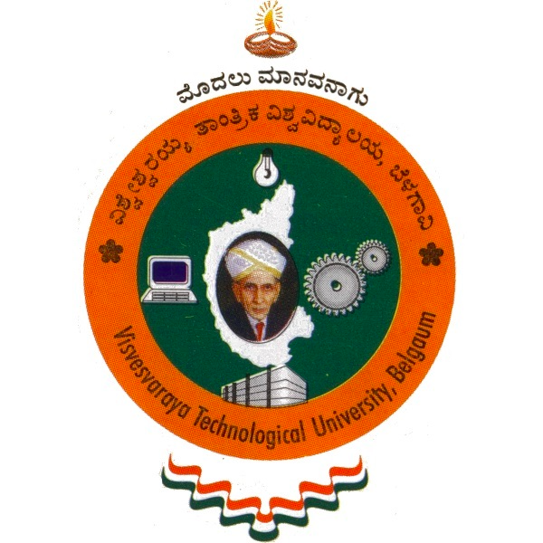

**A Phase-I Project Report**

**on**

**“Patient Readmission Prediction Based On Explainable AI”**

Submitted in partial fulfillment for the award of the degree of

**BACHELOR OF ENGINEERING**

**in**

**INFORMATION SCIENCE AND ENGINEERING**

**Submitted by**

Adithyan R (1CR19IS008)

C Tarun Teja (1CR19IS023)

Chiragraju S( 1CR19IS029)

**Under the Guidance of**

Prof. Sugunadevi C

Assistant Professor

Department of Information Science and Engineering

**DEPARTMENT OF INFORMATION SCIENCE & ENGINEERING**

#132, AECS LAYOUT, IT PARK ROAD, KUNDALAHALLI,

BENGALURU-560037

**2022-23**

**VISVESVARAYA TECHNOLOGICAL UNIVERSITY**

**BELAGAVI-590018, KARNATAKA**



**DEPARTMENT OF INFORMATION SCIENCE & ENGINEERING**

***Certificate***

This is to certify that the long synopsis entitled, “**Patient Readmission Prediction Based On Explainable AI**”, prepared by Adithyan R (1CR19IS008), C Tarun Teja (1CR19IS023), Chiragraju S (1CR19IS029) the bonafide students of CMR Institute of Technology in partial fulfillment of the requirements for the award of **Bachelor of Engineering in Information Science & Engineering** of the Visvesvaraya Technological University, Belagavi -590018 during the academic year 2022-23.

It is certified that all the corrections and suggestions indicated for Internal Assessment have been incorporated in the synopsis deposited in the departmental library. The synopsis has been approved as it satisfies the academic requirements prescribed for the said degree.

**_____________________ _____________________**

**Signature of Guide Signature of HOD**

**Prof. Sugunadevi C Dr. Farida Begam**

**Assistant Professor Professor & HOD**

**Dept. of ISE, CMRIT** **Dept. of ISE, CMRIT**